Supplementary Materials for

Landscape differences among cities alter species’ responses to urbanization

Mason Fidino, Travis Gallo, Elizabeth W. Lehrer, Maureen H. Murray, Cria Kay, Heather A. Sander, Brandon MacDougall, Carmen M. Salsbury, Travis J. Ryan, Julia L. Angstmann, J. Amy Belaire, Barbara Dugelby, Chris Schell, Theodore Stankowich, Max Amaya, David Drake, Sheryl H. Hursh, Adam A. Ahlers, Jacque Williamson, Laurel M. Hartley, Amanda J. Zellmer, Kelly Simon, Seth B. Magle

Correspondence to: [mfidino@lpzoo.org](mailto:mfidino@lpzoo.org)

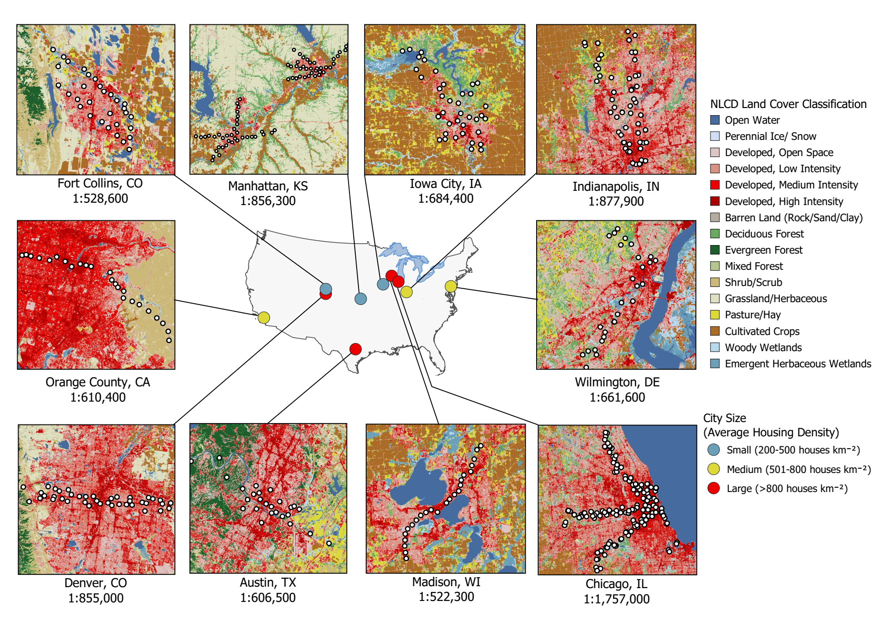

**Fig. S1.** Map of the ten cities sampled for this analysis. White dots within each subfigure represent camera trapping sites. Landcover images derived from the National Landcover Database.

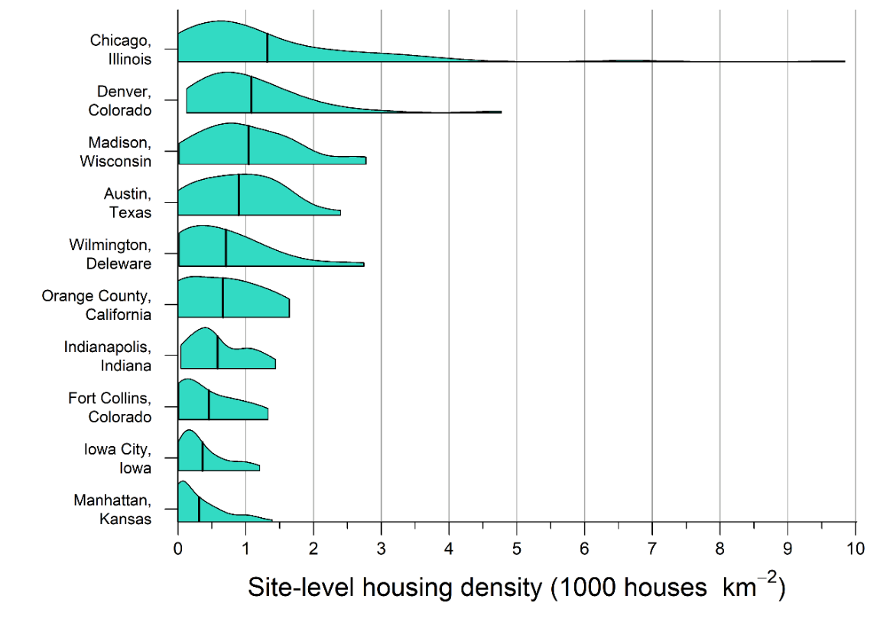

**Fig. S2.** The range and extent of within-city housing density measured at camera trap locations of 10 U.S. cities. Black vertical bars represent the mean housing density across all locations within a city. Housing density was calculated within a 1 km buffer of each camera trap location.

|  |  |  |  |
| --- | --- | --- | --- |
| **Table S1.** The number of functional sites with classified data per year and city. A dash indicates data were not available. | | | |
|  | Number of sites sampled | | |
| City | 2016 | 2017 | 2018 |
| Austin, Texas | - | 25 | - |
| Chicago, Illinois | 97 | 104 | 100 |
| Denver, Colorado | - | 40 | - |
| Fort Collins, Colorado | - | 31 | - |
| Iowa City, Iowa | - | 37 | 39 |
| Indianapolis, Indiana | - | 45 | 43 |
| Orange County, California | - | - | 24 |
| Manhattan, Kansas | 74 | 74 | - |
| Madison, Wisconsin | - | 23 | 24 |
| Wilmington, Delaware | - | - | 28 |

|  |  |  |
| --- | --- | --- |
| **Table S2**. The among-city covariates calculated for each of the 10 U.S. cities where camera trap data was collected. Cities are sorted by mean housing density. | | |
| City | Greenspace availability  (proportion) | Average housing density  (houses km-2) |
| Manhattan, Kansas | 0.63 | 310 |
| Iowa City, Iowa | 0.31 | 360 |
| Fort Collins, Colorado | 0.44 | 450 |
| Indianapolis, Indiana | 0.29 | 590 |
| Orange County, California | 0.42 | 660 |
| Wilmington, Delaware | 0.51 | 710 |
| Austin, Texas | 0.59 | 900 |
| Madison, Wisconsin | 0.24 | 1040 |
| Denver, Colorado | 0.39 | 1090 |
| Chicago, Illinois | 0.18 | 1320 |